# Logging in to Codecademy for the first time

1. Visit the website [www.codecademy.com](http://www.codecademy.com)
2. 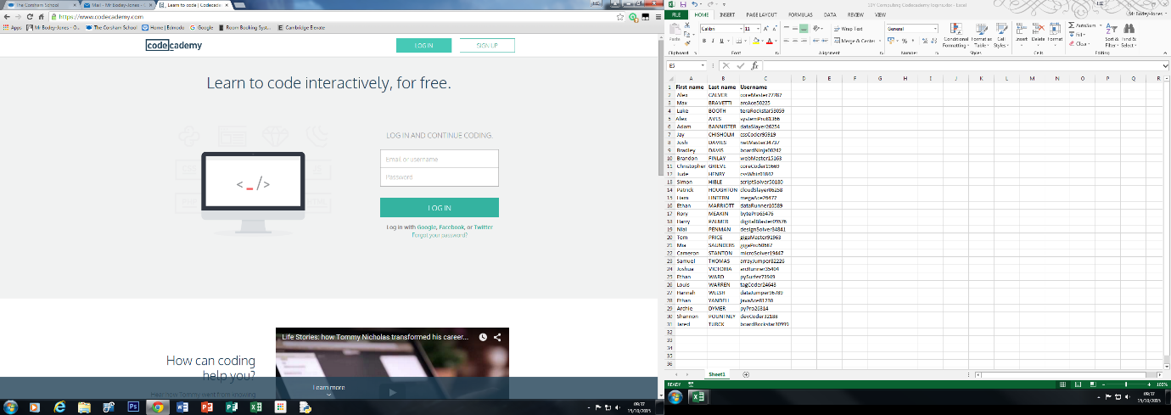From the top right click on Login. You should see boxes for typing in your username and Password. Refer to the information that your teacher has given you for these. Pay particular attention to the username and password a both are case sensitive. When entered click on login
3. Scroll down past the Web Developer Skills and onto language skills. Select Python from this section.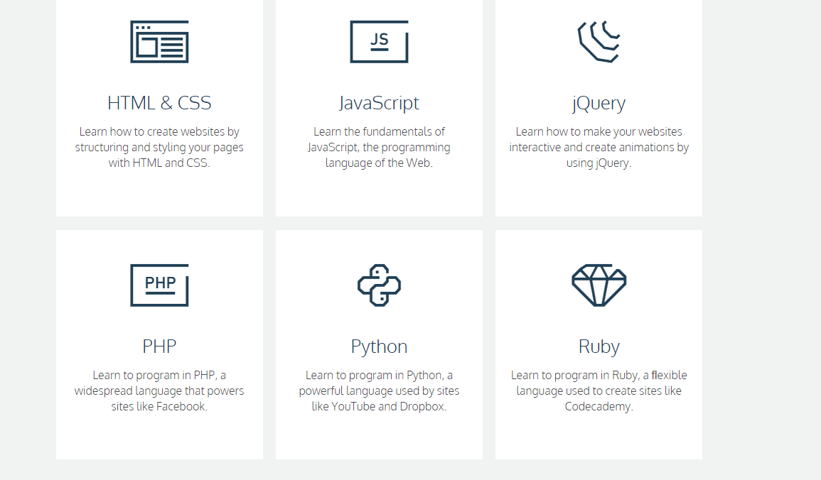
4. From the next page click on start (big red button!). You may want to read through the overview to see what you will be covering.
5. The Codecademy tutorial window will open. It is important the you read the instructions carefully.